Programming Assignment 16

Assignment Goal:

Graphical User Interfaces have a major impact on the productivity of employees. Good screen design is paramount to the usability of any system.

Assignment Specifications:

The Pampered Pet Pet Resort provides boarding services for dogs and cats. **Maximum stay is 30 days.** In addition to boarding, customers may elect for a variety of services.

Boarding fees are based upon the size of the animal’s suite as follows:

Standard Large (Indoor 4' x 6'/Outdoor 4' x 12') $25.00 per day

Standard Extra-Large (Indoor 5' x 6'/Outdoor 5' x 12') $28.00

Standard Double Extra Large (Indoor 8' x 6'/Outdoor 8' x 12') $34.00

Luxury Suite (Indoor 6' x 6' / Outdoor 6' x 12') $40.00

Additional services are as follows:

Delivery of medications $2.50 per dose

Bath & Brush $15.00

Walking $5.00

Pedicure $10.00

Transport to vet $20.00

Sunday pickup $12.50

Resort provided food $5.00 per day

Create a Swing form to calculate the cost of a stay, tax, and final total. A sales tax of 8.125% is charged. Display a summary using a dialog box.

Besides the items above, provide places for the user to enter the owner’s name, owner’s phone number, pet’s name, pet’s age, whether the pet is up to date on shots, whether the pet is a dog or cat, and any special instructions.

Deliverables (what you are to submit):

1. A planning document
   1. Program Outline
   2. Methods
   3. Data items
   4. A prototype screen
   5. Storyboards showing screen interactivity
   6. An OEM chart for the screen elements that require actions.
   7. Testing criteria
2. Your complete project folder in zip format.

CIS163AA Programming Assignment 16 (PamperedPet)

Name: _____Daniel Cender___________________________________

**Program Outline:** < This is an outline of what your program is to do. Be detailed. >

Program will receive input from user in PamperedPet Swing GUI

calculateInvoice() will calculate the total charge for the pet’s stay and generate the invoice message to display

On Submit, the program will display a summary of the customer’s invoice.

On Cancel, the program will exit.

**Methods:** < This is a list of methods you will define in your program. >

|  |  |  |  |  |
| --- | --- | --- | --- | --- |
| **Function** | **Access Modifier(1)** | **Method Name** | **Parameters (dataType identifier)** | **Return Type (2)** |
| Main method: | public static | main() |  | void |
| Calculate Invoice | public | calculateInvoice() |  | void |

1. Access Modifier: local, public, private, protected

2. Return Type: void, string, char, byte, short, integer, long, double, float, boolean, object, etc.

**Data Items:** < This is a list of fields (variables, constants, and objects you will need. >

|  |  |  |  |  |  |
| --- | --- | --- | --- | --- | --- |
| **Data Item** | **Source (1)** | **Access Modifier (2)** | **Data Type (3)** | **Identifier** | **Notes** |
| GUI Title | Instance | local | JLabel | lblTitle |  |
| Owner Name | Instance | local | JLabel | lblOwnerName |  |
| Owner Cell | Instance | local | JLabel | lblOwnerCell |  |
| Pet’s Name | Instance | local | JLabel | lblPetName |  |
| Pet’s Age | Instance | local | JLabel | lblPetAge |  |
| Pet’s Shots | Instance | local | JLabel | lblShots |  |
| Suite Panel | Instance | local | JPanel | pnlSuite |  |
| Services Panel | instance | local | JPanel | pnlServices |  |
| Txt Owner Name | instance | local | JTextField | txtOwnerName |  |
| Txt Owner Cell | instance | local | JTextField | txtOwnerCell |  |
| Txt Pet Name | instance | local | JTextField | txtPetName |  |
| Txt Pet age | instance | local | JTextField | txtPetAge |  |
| Rad Up To Date | instance | local | JRadioButton | radUpToDate |  |
| Rad Not Up To Date | instance | local | JRadioButton | radNotUpToDate |  |
| Type of Pet | instance | local | JLabel | lblTypeOfPet |  |
| Type Panel | instance | local | JPanel | pnlType |  |
| Type Cat | instance | local | JRadioButton | radTypeCat |  |
| Type Dog | instance | local | JRadioButton | radTypeDog |  |
| Services | instance | local | JLabel | lblServices |  |
| Chk Meds | instance | local | JCheckButton | chkMeds |  |
| Chk Bath/Brush | instance | local | JCheckButton | chkBathBrush |  |
| Chk Walking | instance | local | JCheckButton | chkWalking |  |
| Chk Pedicure | instance | local | JCheckButton | chkPedicure |  |
| Chk Transport | instance | local | JCheckButton | chkTransport |  |
| Chk SundayPickup | Instance | local | JCheckButton | chkSundayPickup |  |
| Chk Resort Provided Food | Instance | local | JCheckButton | chkFood |  |
| Button Cancel | Instance | local | JButton | btnCancel |  |
| Button Submit | Instance | local | JButton | btnSubmit |  |
| Lbl Special Instructions | Instance | local | JLabel | lblSpecialInstructions |  |
| lbl Pet Age | Instance | local | JLabel | lblPetAge |  |
| lbl Suite Size | instance | local | JLabel | lblSuiteSize |  |
| lbl Stay Length | Instance | local | JLabel | lblStay |  |
| txt Stay Length | Instance | local | JTextField | txtStay |  |
| lbl Doses | Instance | local | JLabel | lblDoses |  |
| txt Doses | Instance | local | JTextField | txtDoses |  |
| txaSpecialInstructions | Instance | local | JTextArea | txaSpecialInstructions |  |

1. Source (where the data comes from): calculated, input, constant, parameter, instance, object

2. Access Modifier: local, public, private, protected

3. Data Type: string, char, byte, short, integer, long, double, float, boolean, object, etc.

**Sample Output:** < What will the user see? >

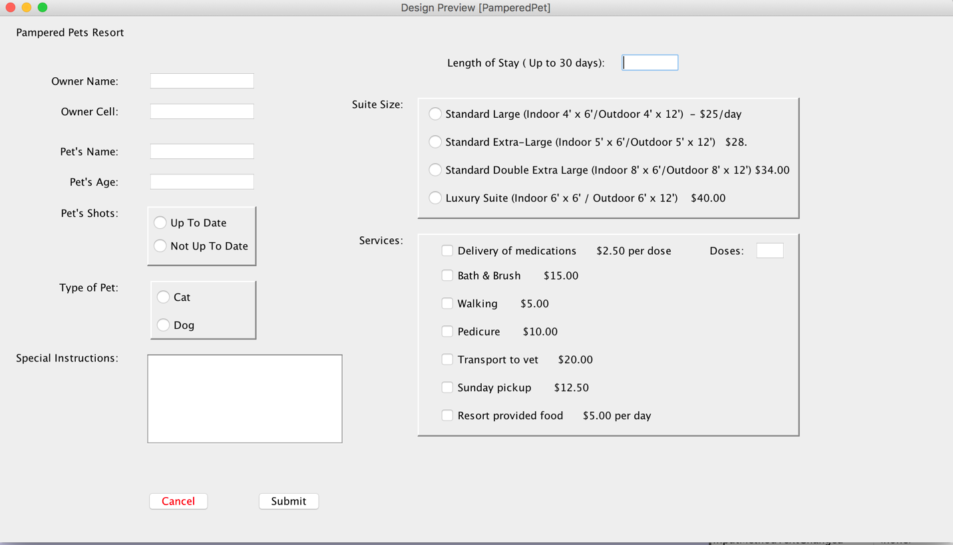

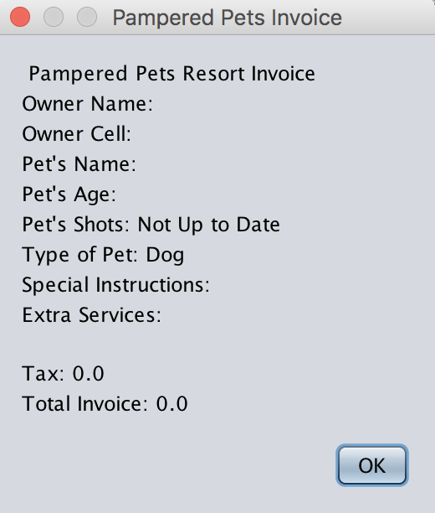

**Test Data:** < How will you prove your program works? >

|  |  |  |  |  |
| --- | --- | --- | --- | --- |
| Identifier | Case 1 | Case 2 | Case 3 | Case 4 |
| txtOwnerName | Billy Bob | Jill Jones | Bobby | Penny Rose |
| txtOwnerCell | 602-602-6022 | 77 | 450-999-1111 | 345-667-2221 |
| txtPetName | Puppy | Sadie | George | Bobby |
| txtPetAge | 5 | 9 | 1 | 13 |
| radUpToDate | X |  | X | X |
| radNotUpToDate |  | X |  |  |
| radTypeDog | X |  | X |  |
| radTypeCat |  | X |  | X |
| txaSpecialInstructions | None | Lorem Ipsum | Nope | Must be played with. |
|  |  |  |  |  |
| txtStay (length of stay) | 30 | 3 | 36 | 12 |
|  |  |  |  |  |
| radSuiteLarge |  |  | X |  |
| radSuiteXLarge | X |  |  | X |
| radSuiteXXLarge |  |  |  |  |
| radSuiteLux |  | X |  |  |
|  |  |  |  |  |
| chkMeds |  | X |  |  |
| txtDoses |  | 5 |  |  |
| chkBathBrush | X |  | X | X |
| chkWalking |  | X | X |  |
| chkPedicure |  | X |  |  |
| chkTransport |  | X |  | X |
| chkSundayPickup | X |  |  |  |
| chkFood |  |  | X | X |
|  |  |  |  |  |
| tax | 70.48 | 13.61 | Results in Alert | 35.01875 |
| paymentTotal | 937.98 | 181.109 |  | 466.01875 |

Note: You made more or fewer test cases depending on your application.

**Object Dictionary:**

List each screen object’s name, the event that will respond, and the method that will be called for that event. Depending upon your design, some or many items many not have a method call.

|  |  |  |  |  |
| --- | --- | --- | --- | --- |
| **Screen Object (1)** | **Screen Identifier** | **Local Variable**  **(dataType identifier)** | **Event** | **Event Handler Method** |
| Submit Button | btnSubmit |  | Click Action Event | btnSubmitActionPerformed() |
| Cancel Button | btnCancel |  | Click Action Event | btnCancelActionPerformed() |
| Title Label | lblTitle |  |  |  |
| Owner Name Label | lblOwnerName |  |  |  |
| Owner Name Text | txtOwnerName |  |  |  |
| Owner Cell Label | lblOwnerCell |  |  |  |
| Owner Cell Text | txtOwnerCell |  |  |  |
| Pet Name Label | lblPetName |  |  |  |
| Pet Name Text | txtPetName |  |  |  |
| Pet Age Label | lblPetAge |  |  |  |
| Pet Age Text | txtPetAge |  |  |  |
| Pet Shots Label | lblPetShots |  |  |  |
| Up to Date Radio Button | radUpToDate |  |  |  |
| Not Up To Date Radio Button | radNotUpToDate |  |  |  |
| Type Pet Label | lblTypeOfPet |  |  |  |
| Type Cat Radio Button | radTypeCat |  |  |  |
| Type Dog Radio Button | radTypeDog |  |  |  |
| Special Instructions Label | lblSpecialInstructions |  |  |  |
| Special Instructions Text Area | txaSpecialInstructions |  |  |  |
| Stay Label | lblStay |  |  |  |
| Stay Text Field | txtStay |  |  |  |
| Suite Size Label | lblSuiteSize |  |  |  |
| Large Suite Radio Button | radSuiteLarge |  |  |  |
| XLarge Suite Radio Button | radSuiteXLarge |  |  |  |
| XXLarge Suite Radio Button | radSuiteXXlarge |  |  |  |
| Luxury Suite Radio Button | radSuiteLux |  |  |  |
| Services Label | lblServices |  |  |  |
| Meds Checkbox | chkMeds |  |  |  |
| Doses Label | lblDoses |  |  |  |
| Doses Text Field | txtDoses |  |  |  |
| Bath & Brush Checkbox | chkBathBrush |  |  |  |
| Walking Checkbox | chkWalking |  |  |  |
| Pedicure Checkbox | chkPedicure |  |  |  |
| Transport Checkbox | chkTransport |  |  |  |
| Sunday Pickup Checkbox | chkSundayPickup |  |  |  |
| Resort Food Checkbox | chkFood |  |  |  |
| Type Panel | pnlType |  |  |  |
| Shots Panel | pnlShots |  |  |  |
| Suite Panel | pnlSuite |  |  |  |
| Services Panel | pnlServices |  |  |  |

1. label, text box, radio button, check box, list box, button, group box, panel, menu, tool bar, etc.

**Storyboard/Interactivity Diagram:**

The storyboard/interactivity diagram shows how your screens interact with each other. These are rectangle object with screen names and arrows pointing from one screen to another. Think of this as a screen flowchart.

Totals MessageBox

On clicking “submit”

PamperedPet

On clicking Cancel

Exit Program